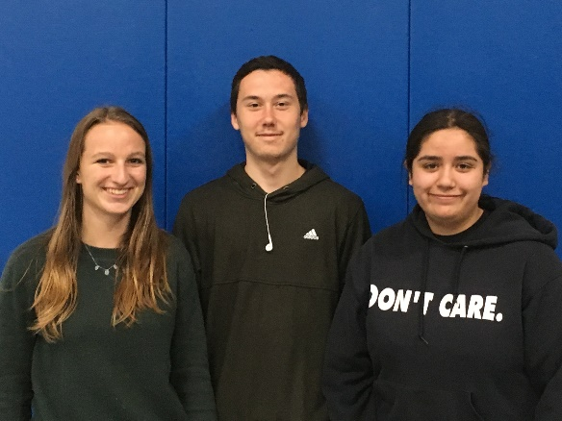

Gualala Arts Awards Scholarships to Three Promising Young Artists

Gualala Arts has awarded scholarships to three outstanding young local high school students. We are delighted to be able to provide scholarships for these three excellent students.

Julie Hidalgo is a talented photographer. Due to a lack of a photography program at Point Arena High School, she is primarily self-taught. She shared photos on a wide variety of subjects with the scholarship committee and spoke passionately about her dream of working for National Geographic. Toward this end, she plans on attending Santa Rosa Junior College to take advantage of their excellent photography program, and to complete her general education requirements before transferring to Academy of Art in San Francisco. She has already been accepted, but will defer her attendance.

Willa Cordrey is multi-faceted. She draws and has worked with prints and batik on fabric. She plans on attending Mills College, after a gap year, with the aim of becoming an elementary school teacher. She will use art extensively in her classroom as a path to teach and inspire her future students.

Sebastian Reaves is also a talented artist, showing us several wonderful drawings. He plans, however, to pursue the Culinary Arts. To that end he will attend Mendocino Junior College in the fall and enroll in their Culinary Arts Program. He hopes someday to be a chef.

Since the Young Artists Scholarship Program was launched in 2000, Gualala Arts has encouraged local talent with the award of more than 30 scholarships, totaling more than $50,000. Awards go to young and talented graduating seniors with a strong commitment and a record of achievement and distinction in their fields of art. Eligibility also includes local residency and firm, realistic plans to further a career in the arts. Applicants submit a written application, school records, letters of support, and the finalists, bring examples of their work to an interview.

This scholarship is a wonderful way to encourage young artists according to the Gualala Arts Young Artists scholarship committee consisting of Nancy Kyle, Jane Head, Hal Fogel, Sandy Hughes and Francie Angwin, and to fulfill a mission of Gualala Arts. The scholarship helps to support the career development of our local talent by first, recognizing and honoring a young person’s commitment to a chosen field of art, and second, by helping with the considerable expenses of further study.

We are very grateful to the Pacific Piecemakers Quilt Guild for their donation of a beautiful quilt to the Gualala Arts Center each year. The quilt is then raffled off with the drawing of the winning ticket at Art in the Redwoods. The proceeds go to support this scholarship, and to fund a scholarship at the Art Center summer camp. We would not be able to offer this wonderful opportunity to our youth without their generous donation.

The Gualala Arts Young Artists Scholarship

